**Git Tutorial**

<https://www.youtube.com/watch?v=UF8prUYlA98>

How to add SSH key for security so that no one can push code in my remote repository

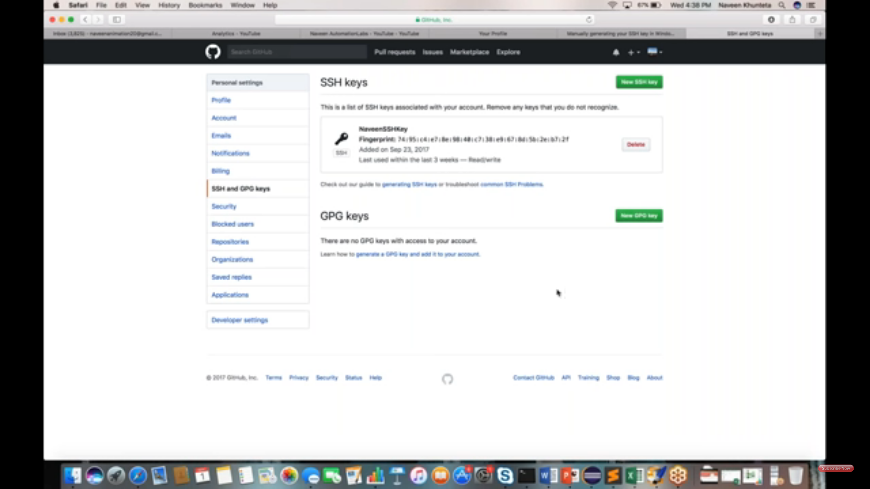

Generating SSH key from the url

<https://docs.joyent.com/public-cloud/getting-started/ssh-keys/generating-an-ssh-key-manually/manually-generating-your-ssh-key-in-windows>

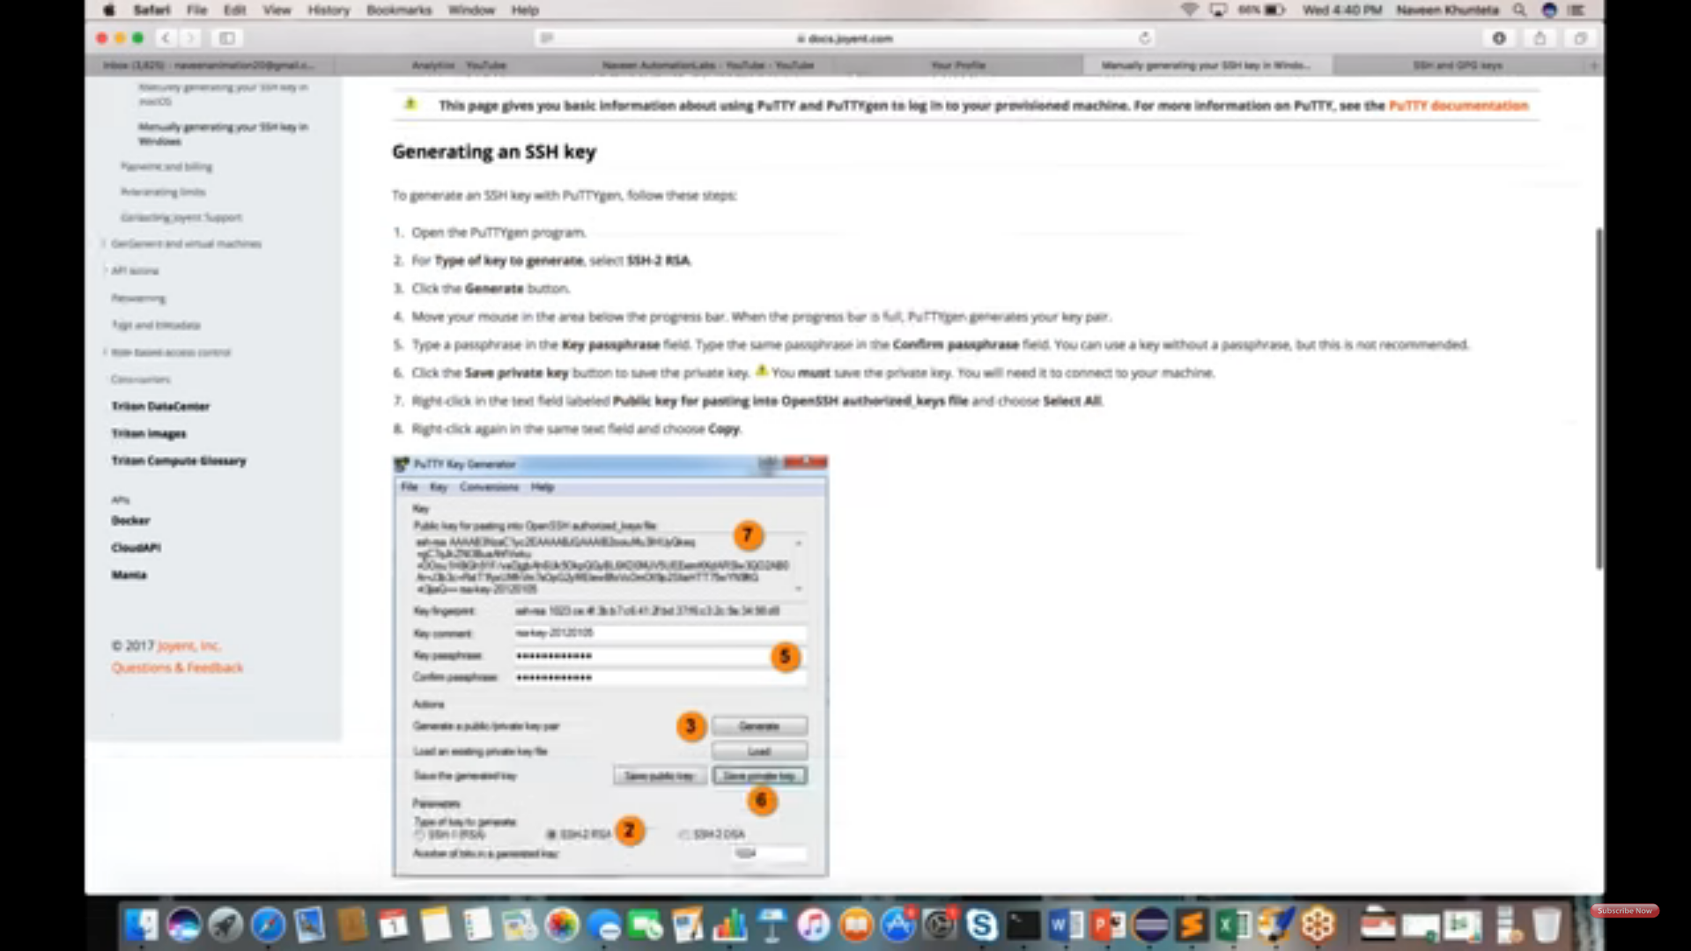

Git features

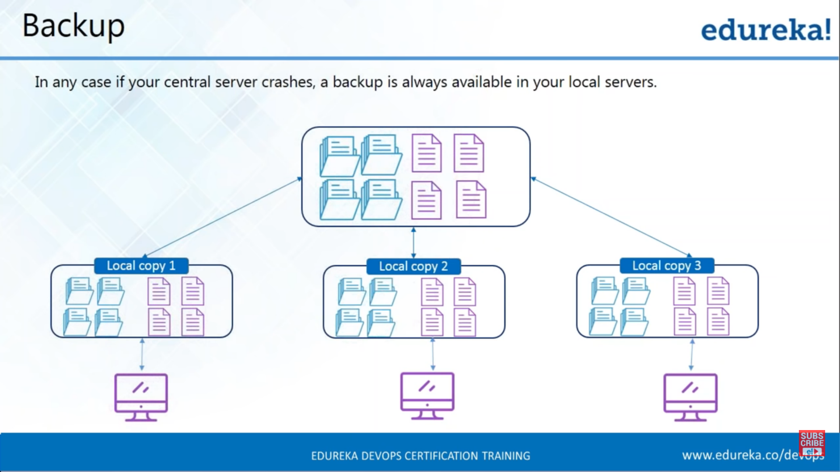

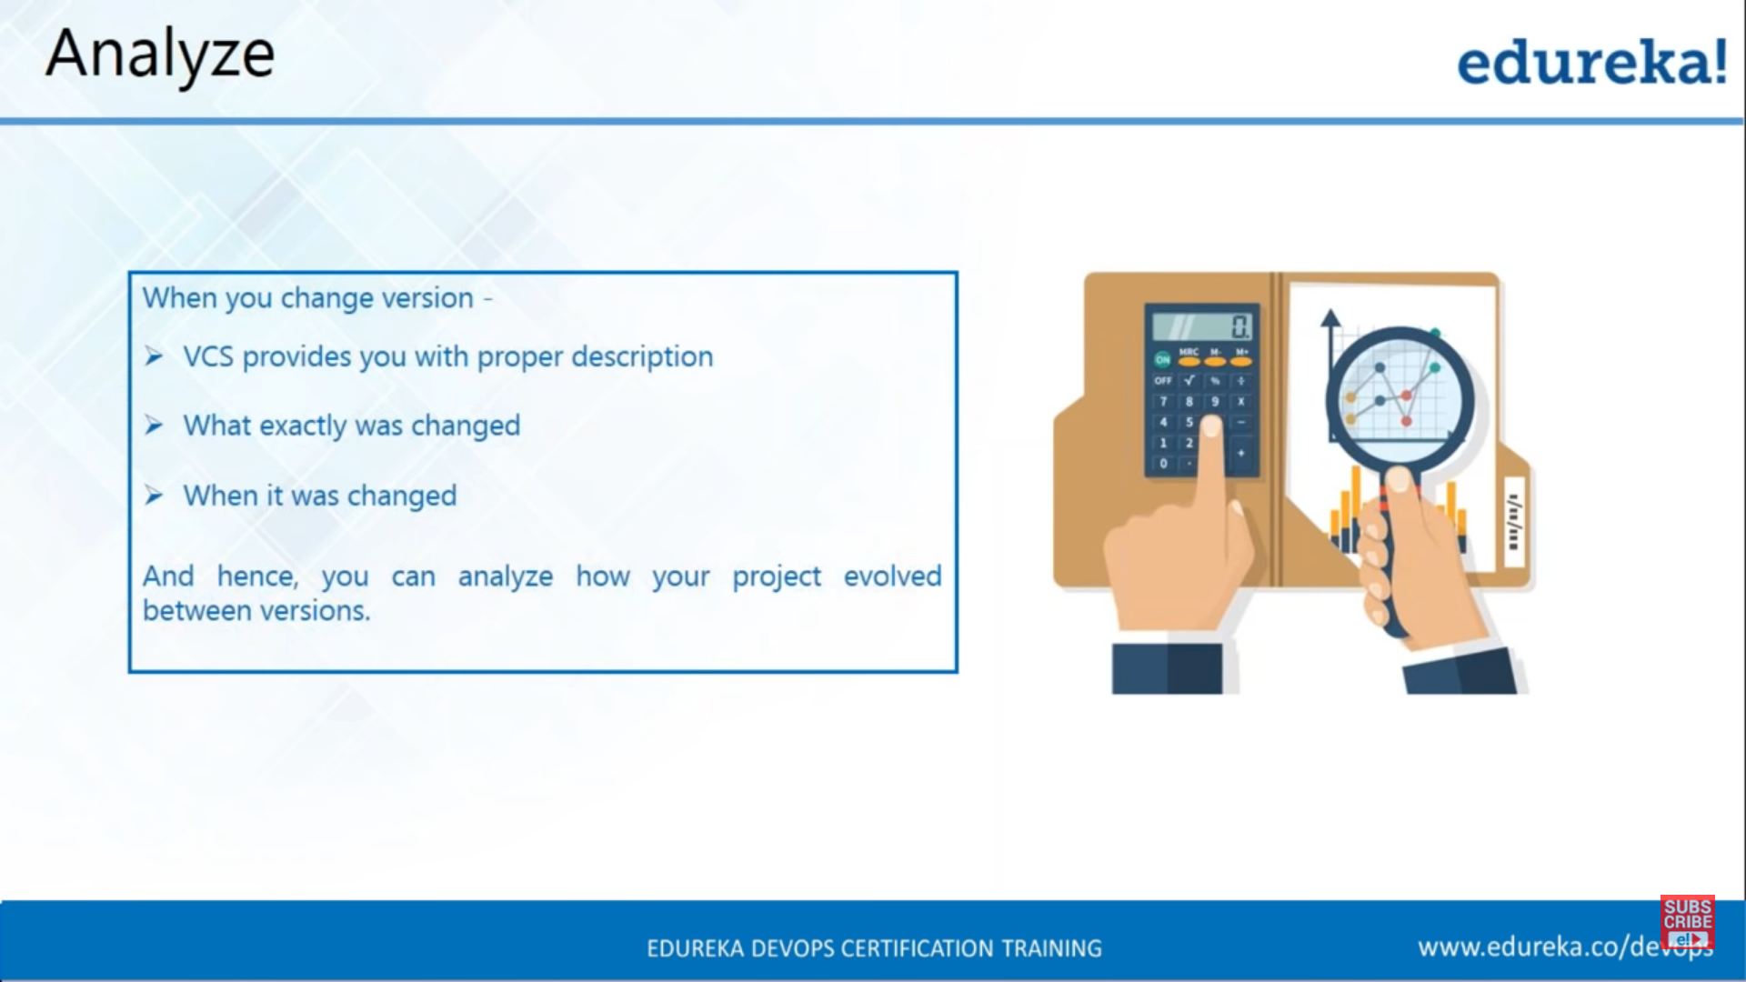

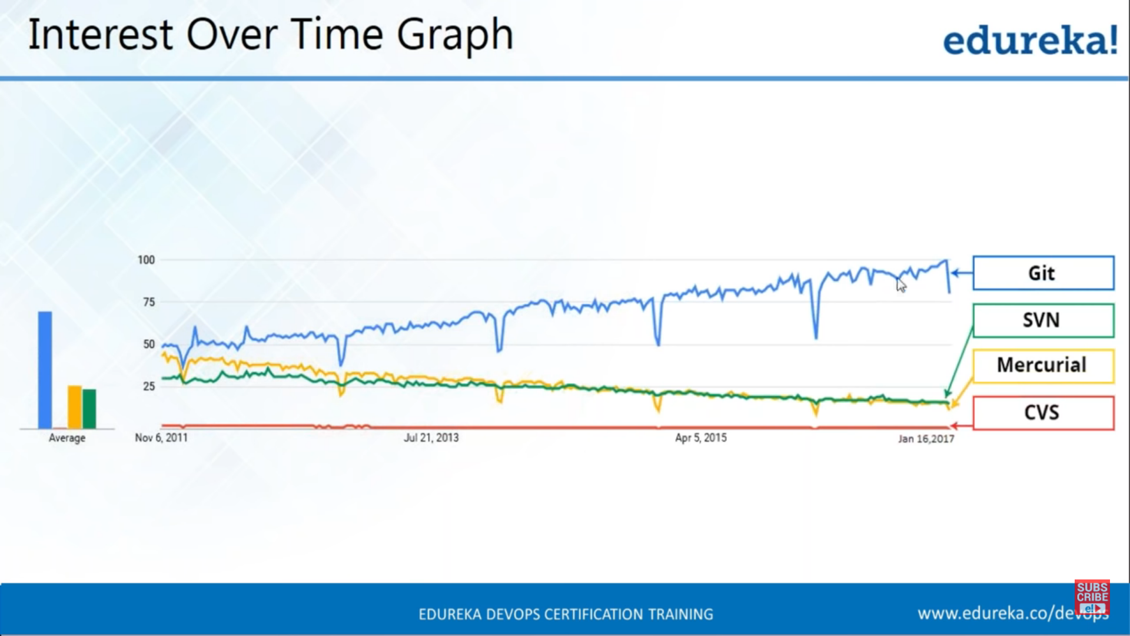

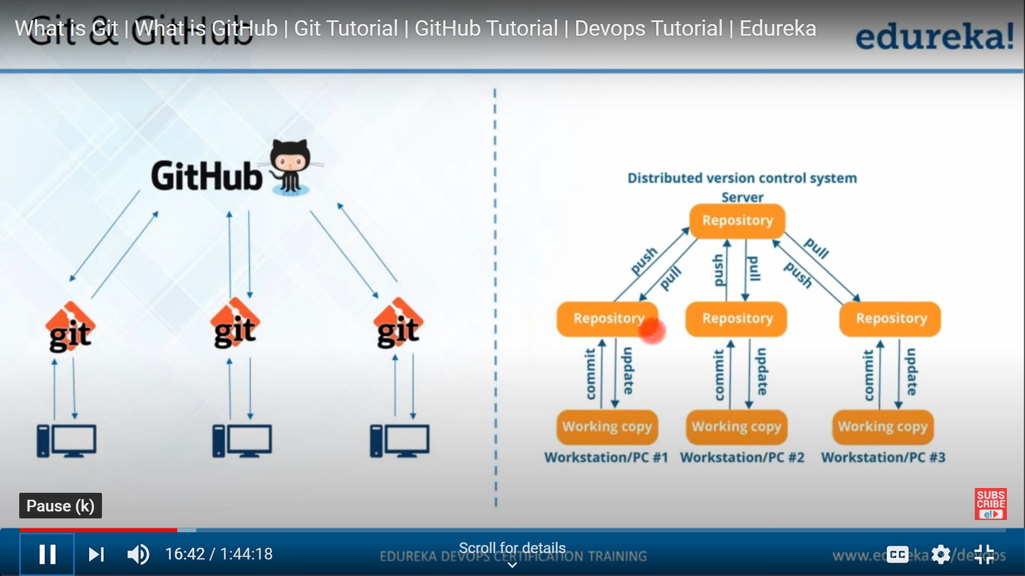

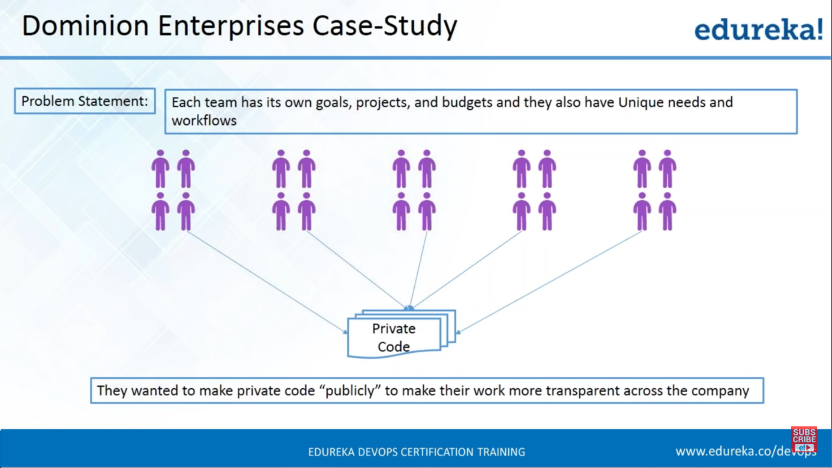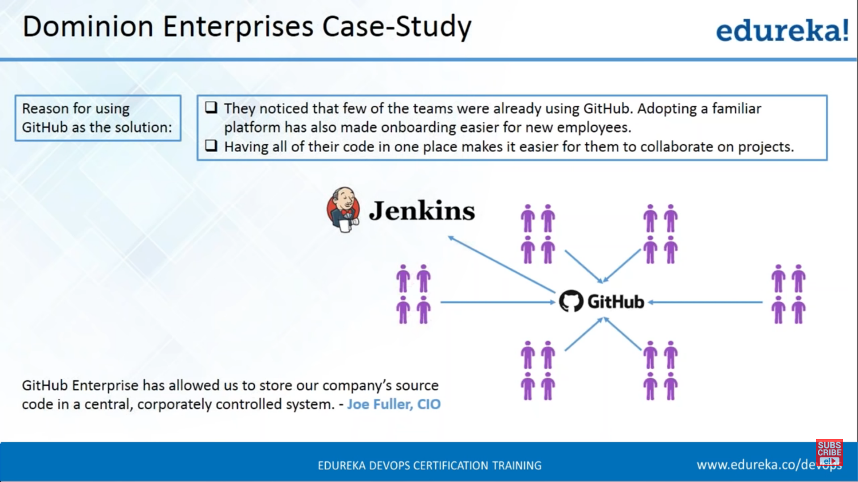

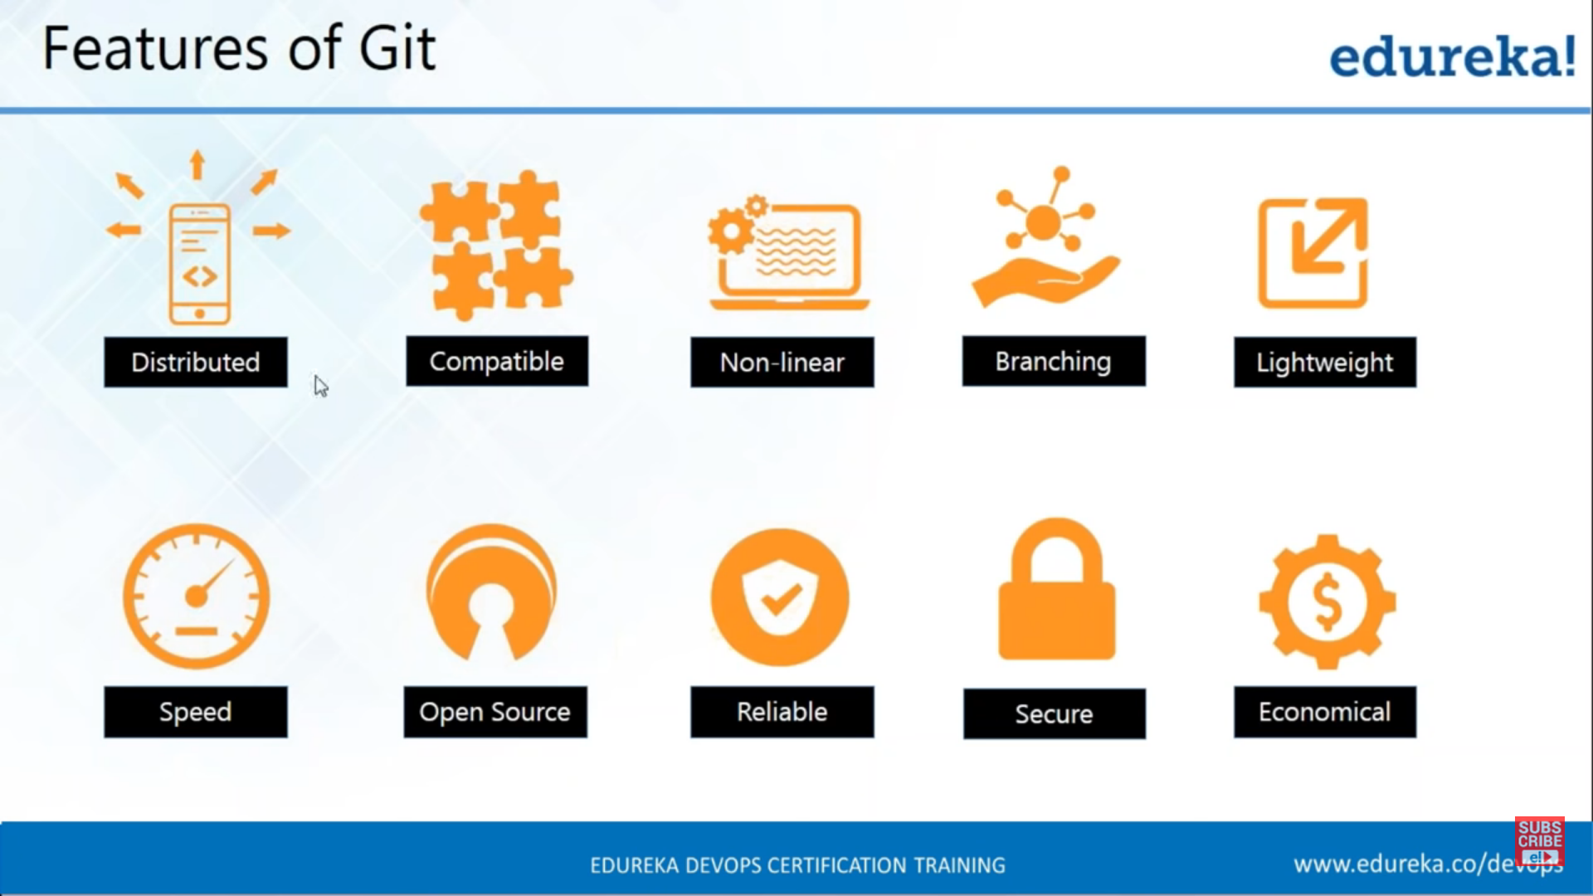

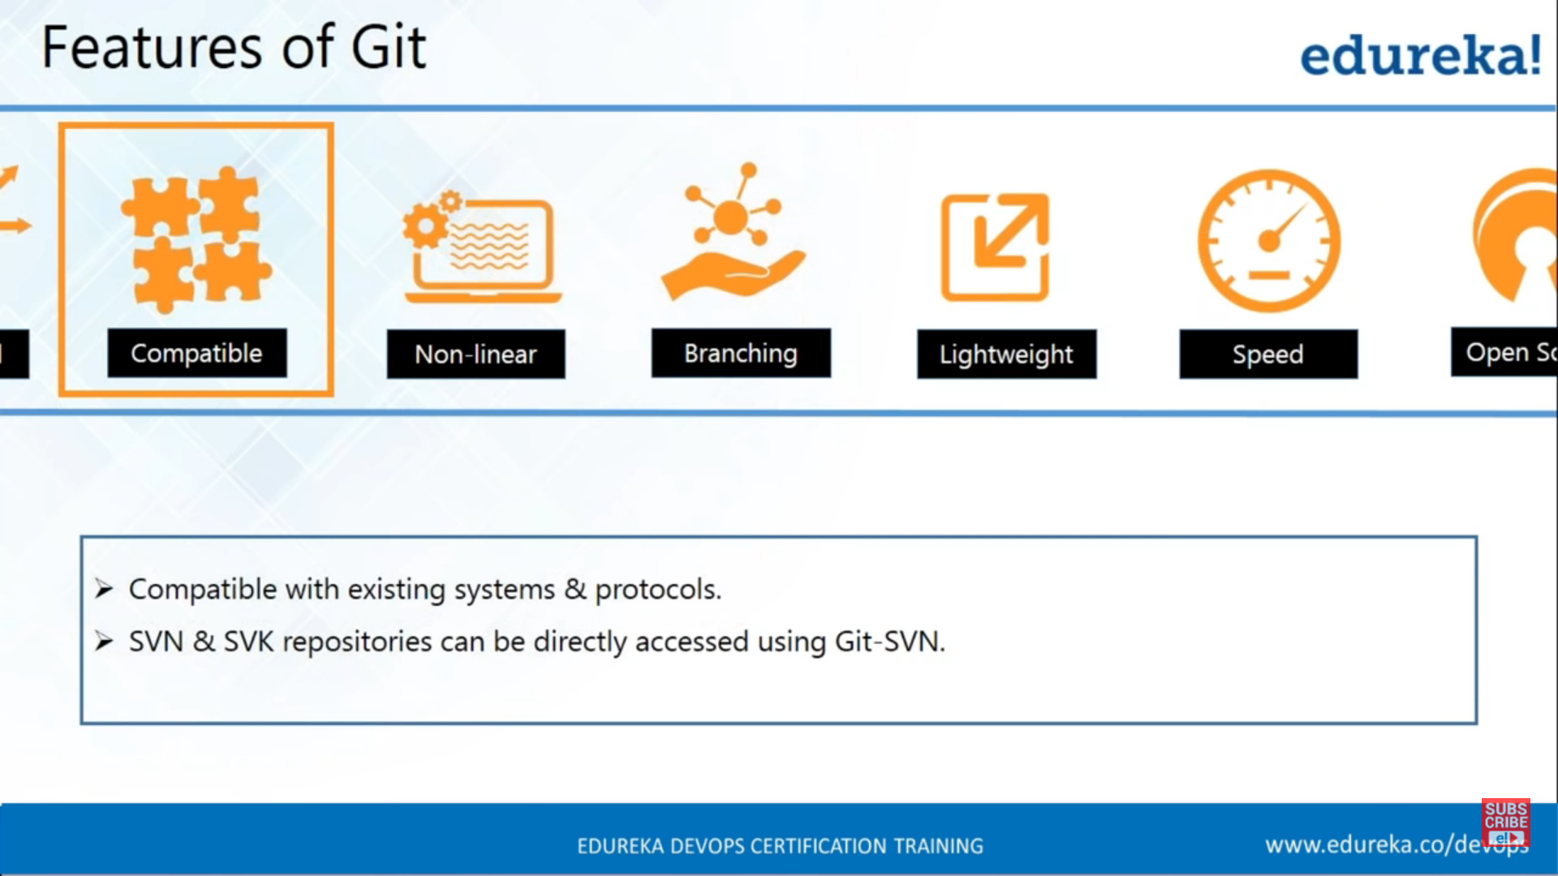

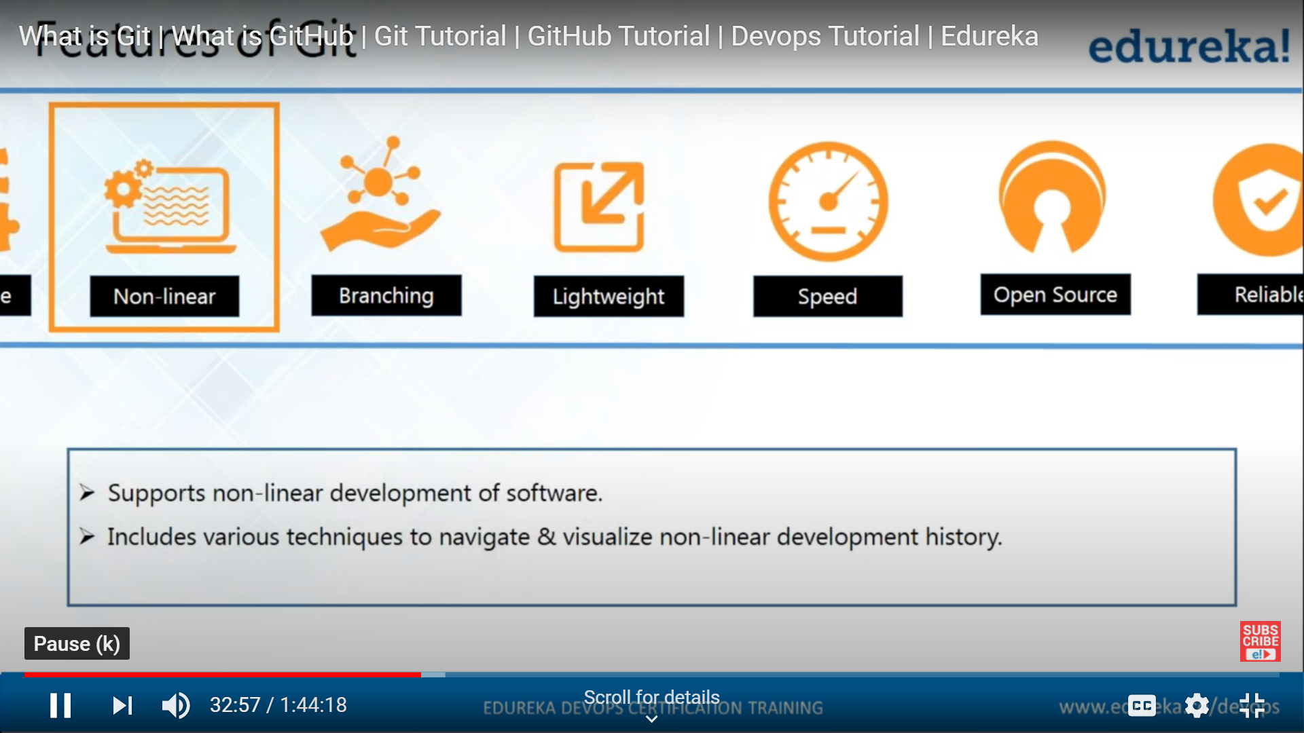

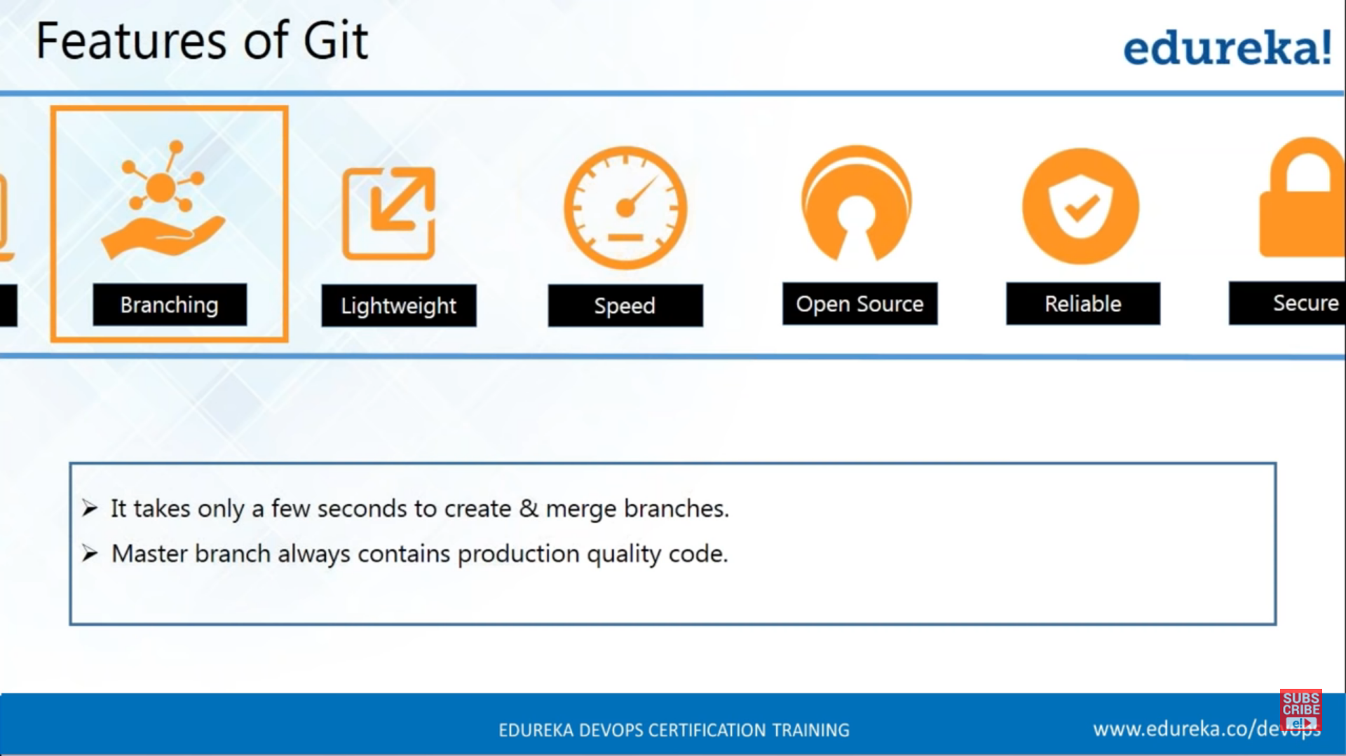

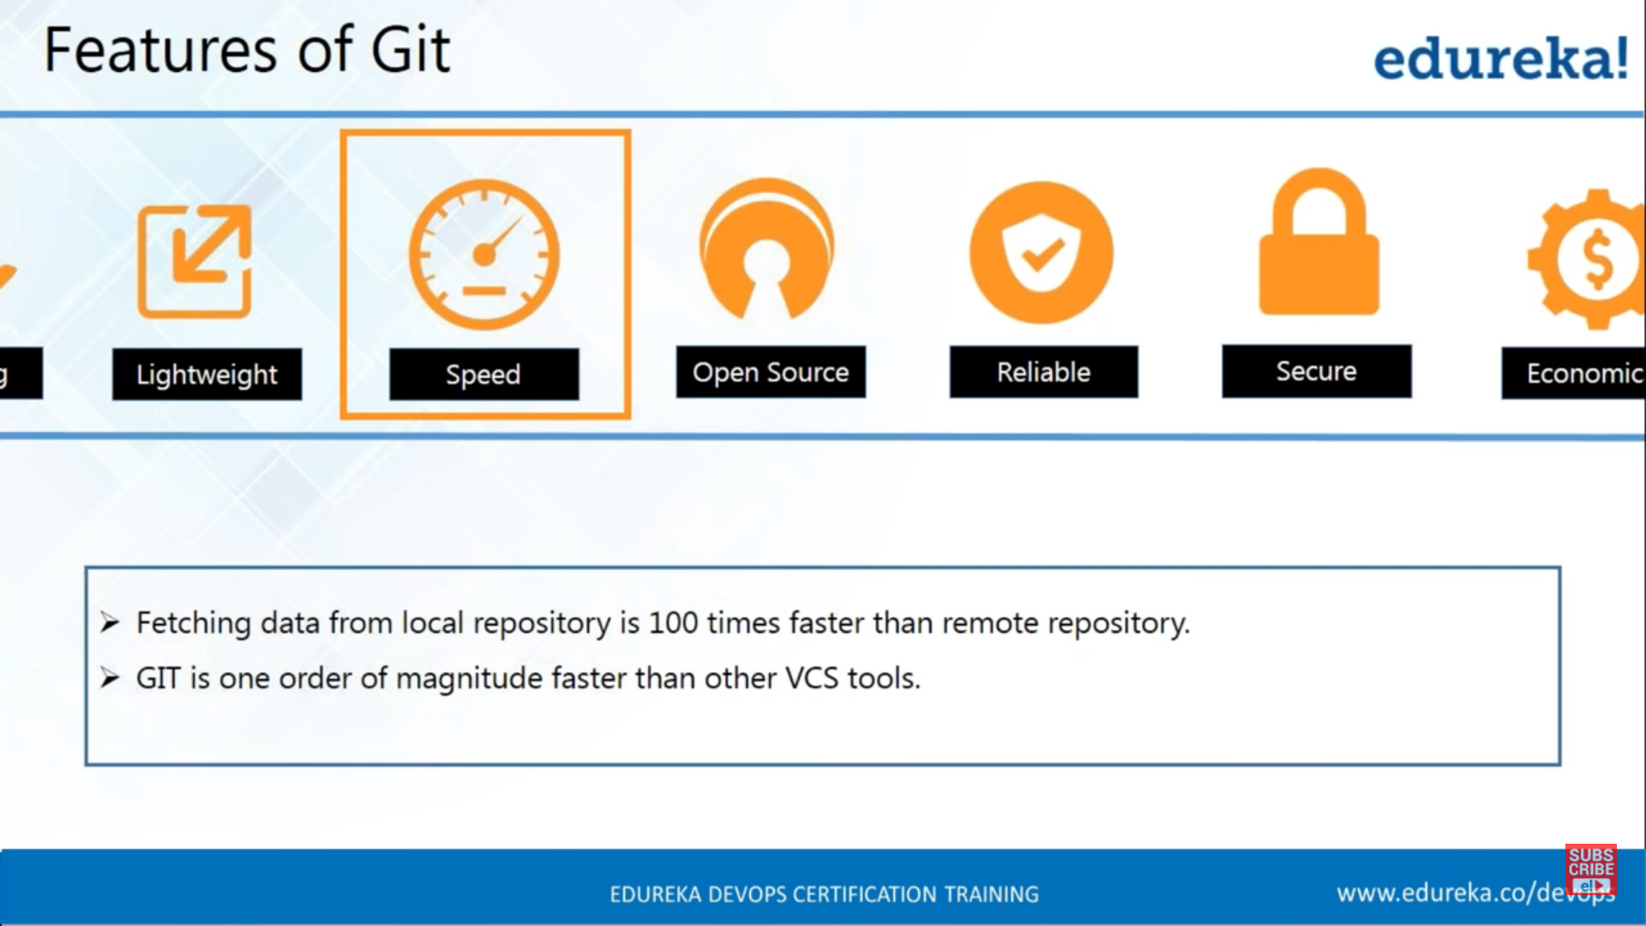

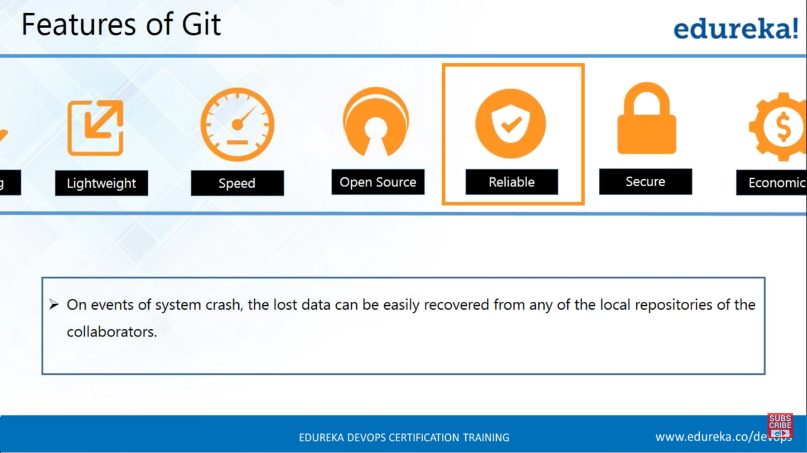

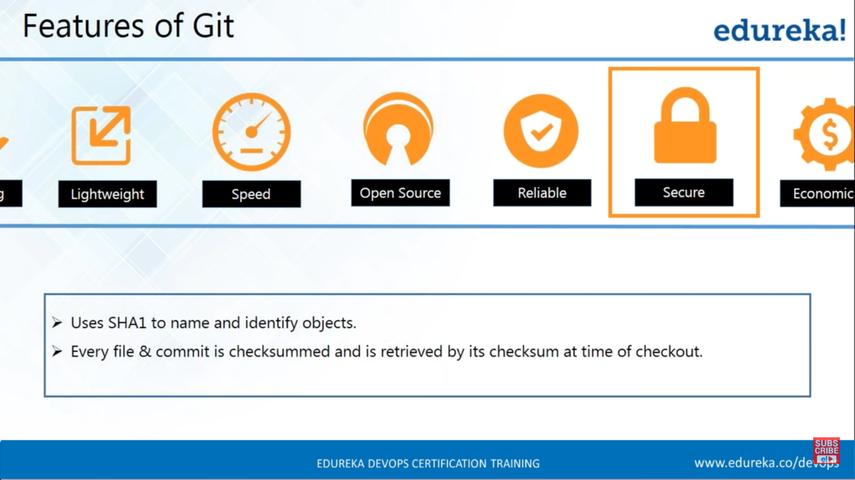

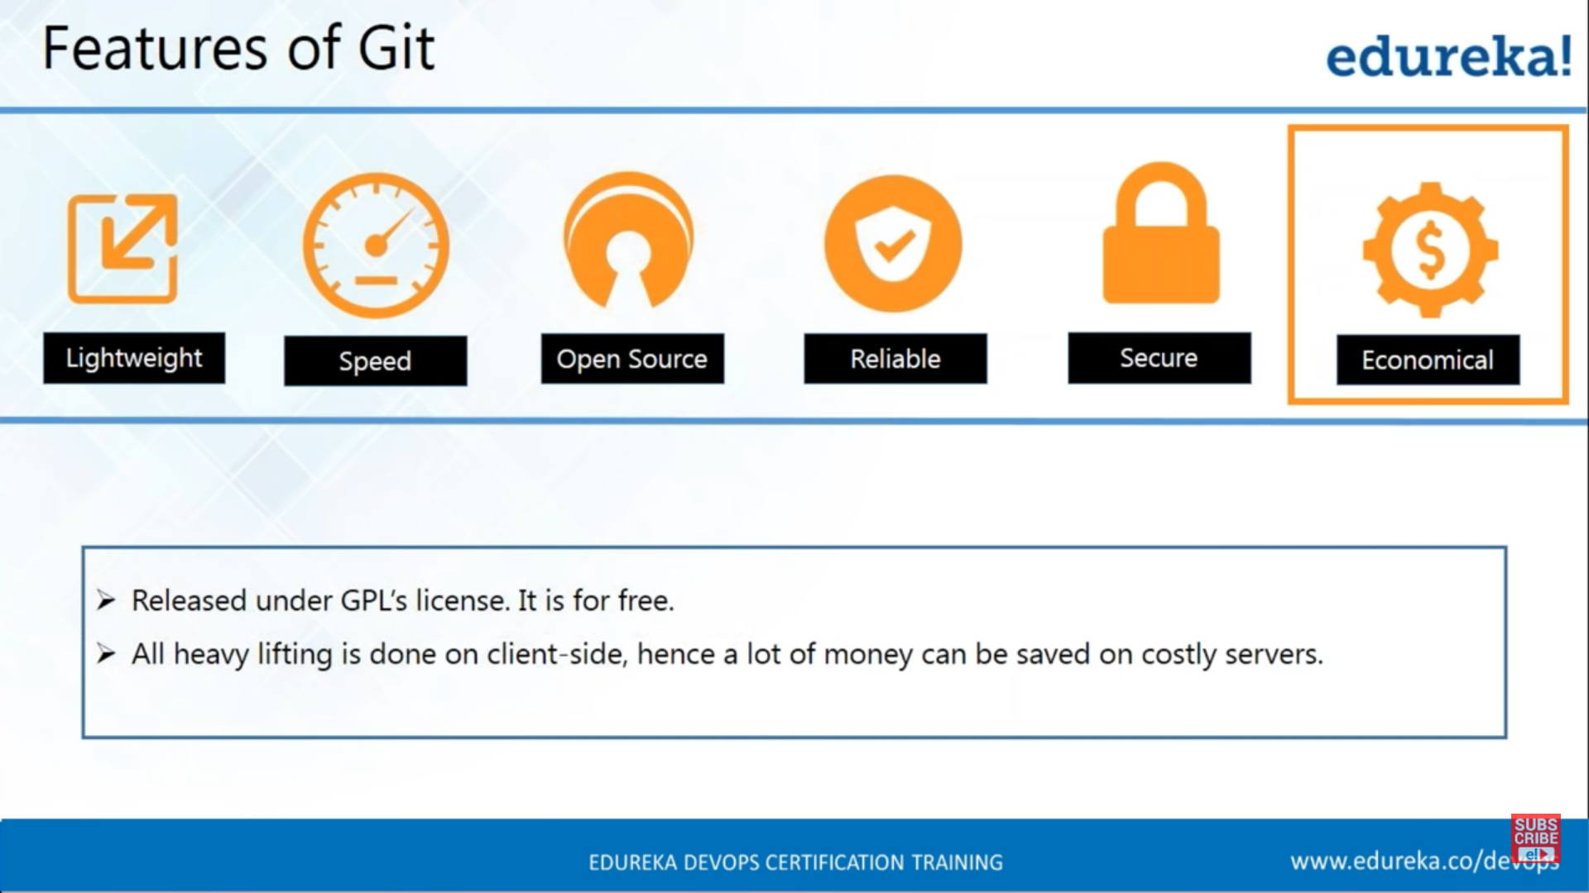

Repository-

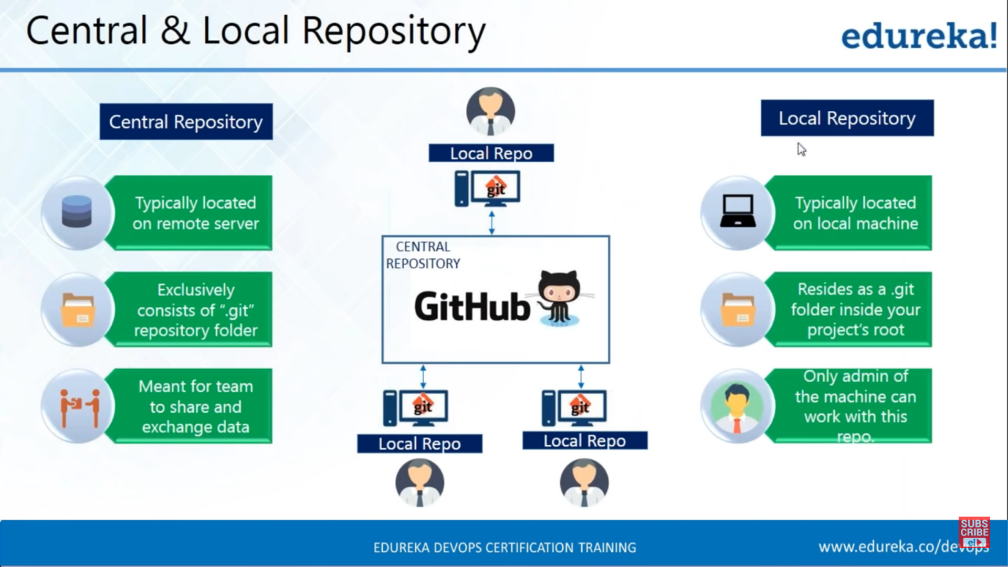

Git operations and commands

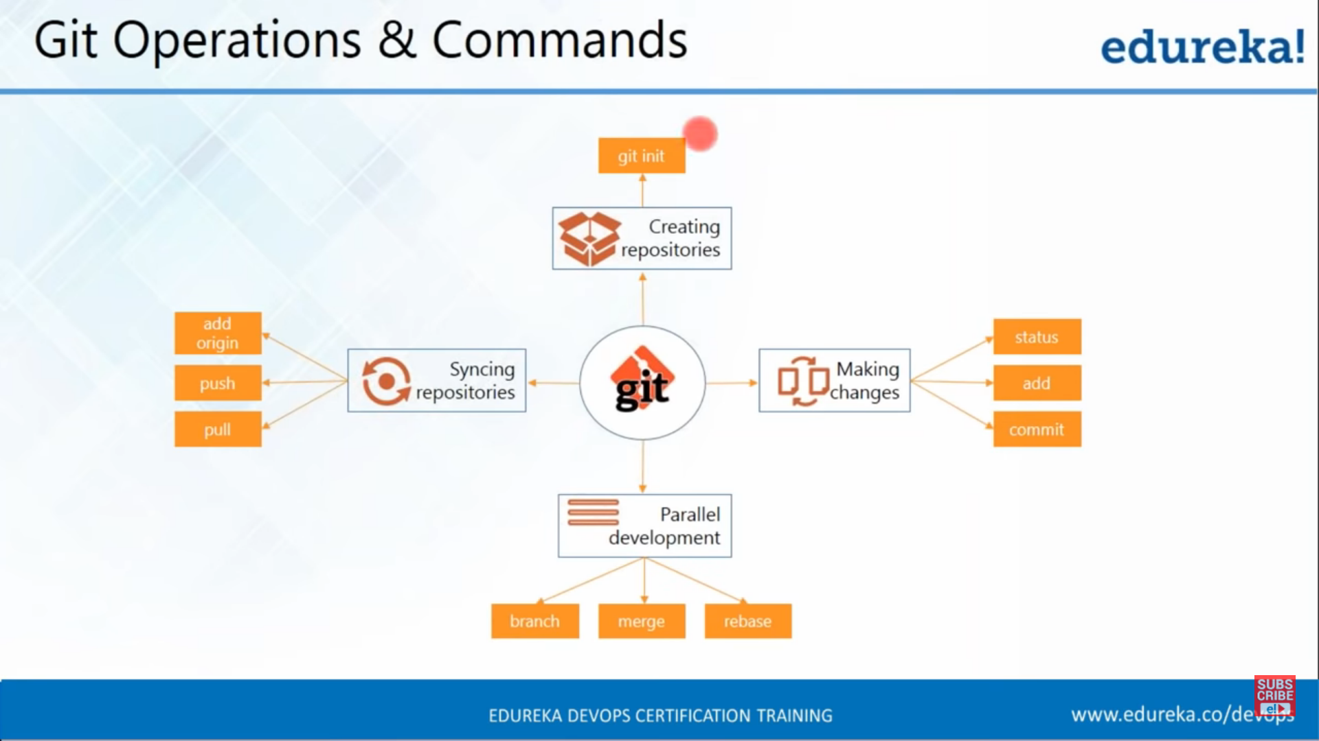

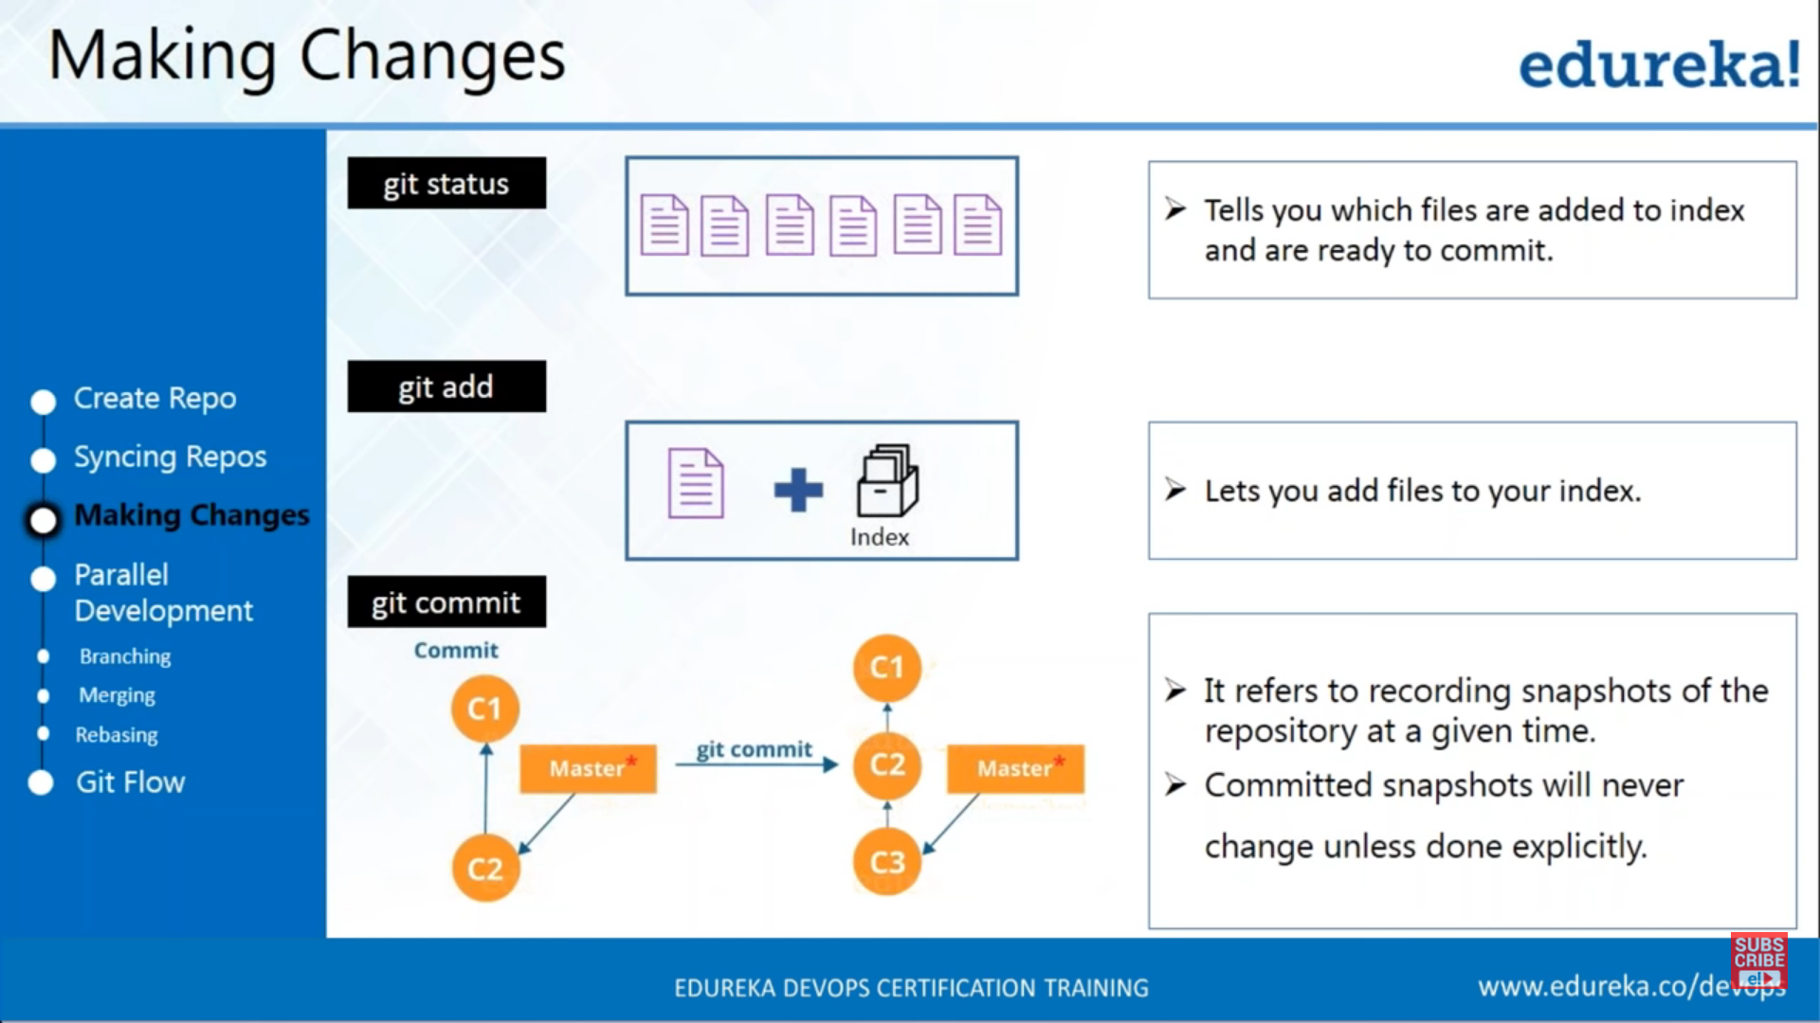

Branching

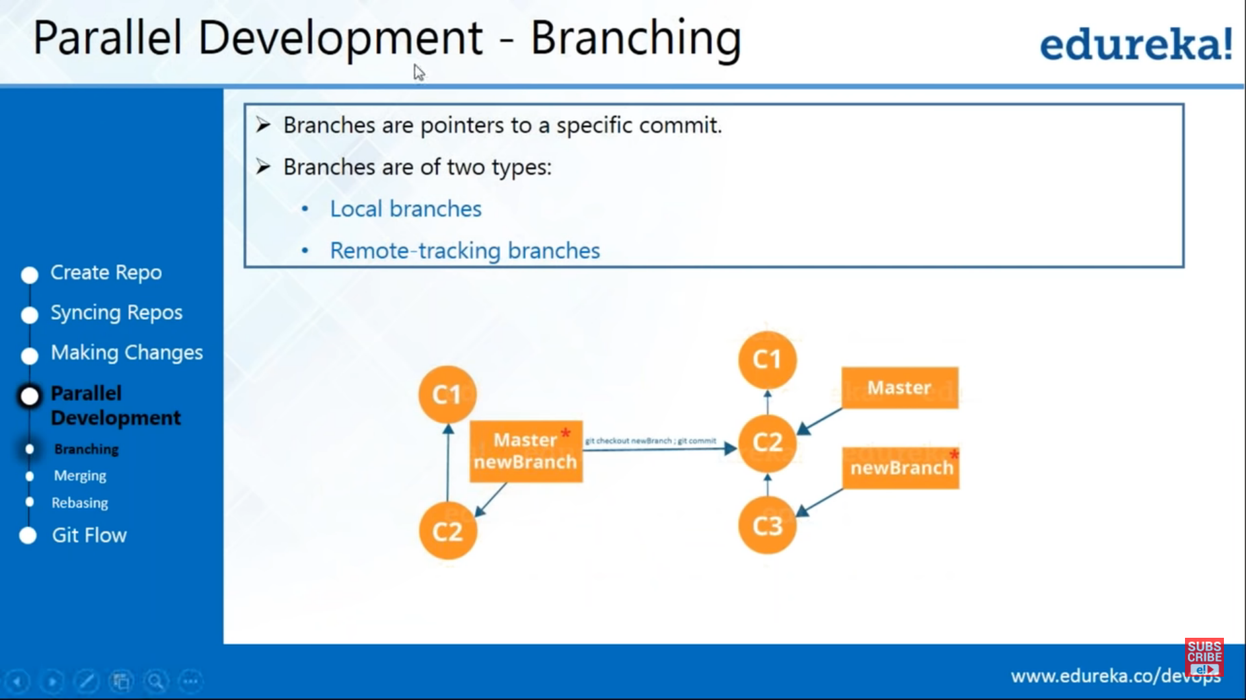

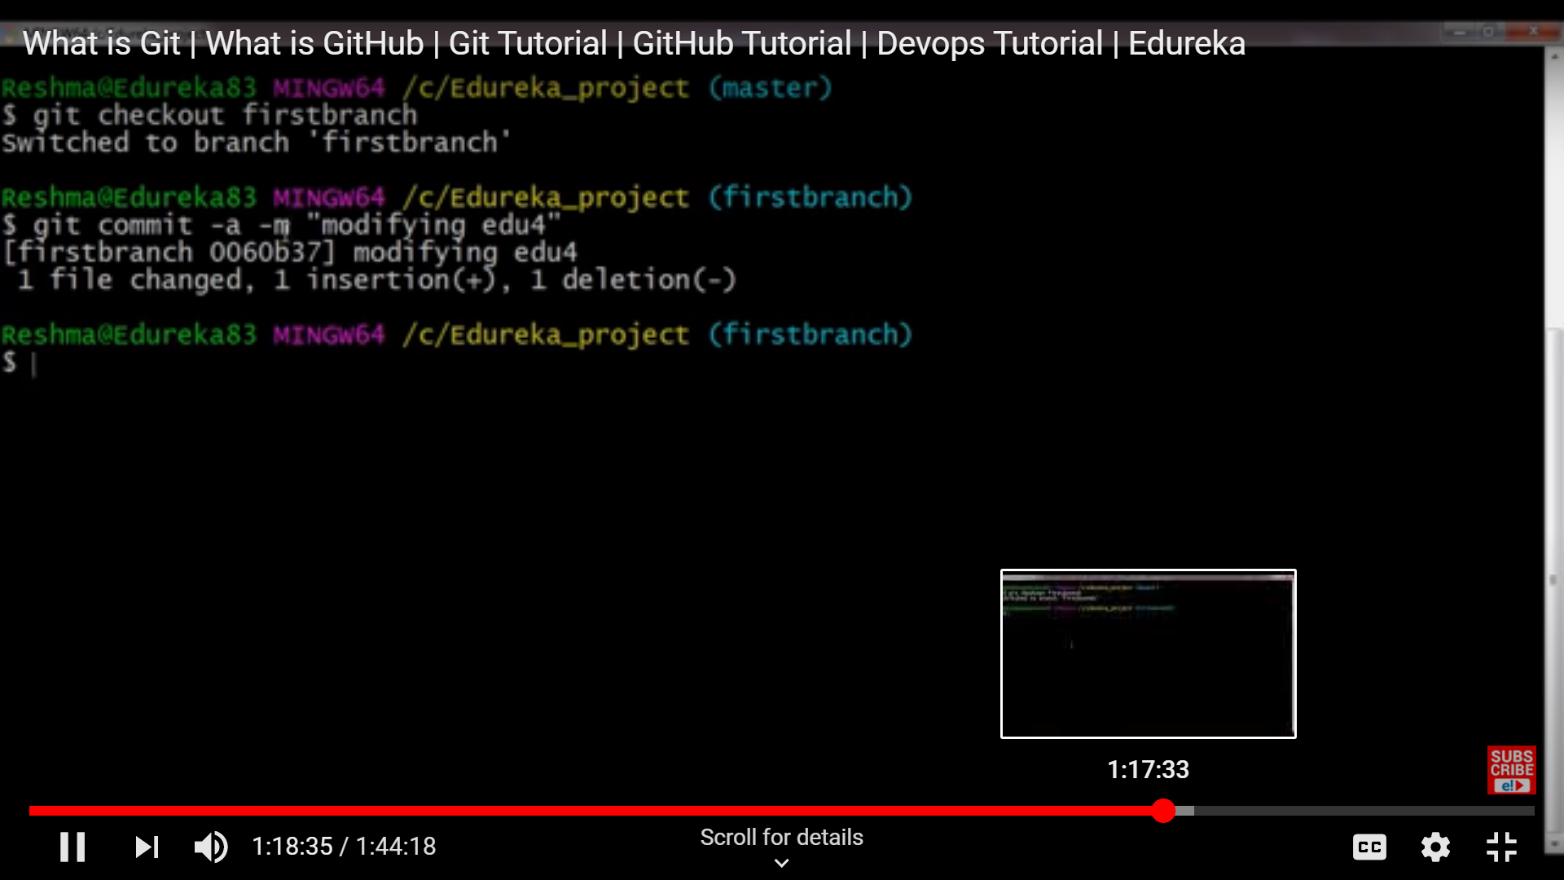

Git branching concept

Pull request (PR): Raise a PR -> Raise a Pull request. I (reviewer0 will review it.)

<https://www.youtube.com/watch?v=iJNuZw0ur2E&list=RDCMUCXJKOPxx4O1f63nnfsoiEug&start_radio=1&t=350>

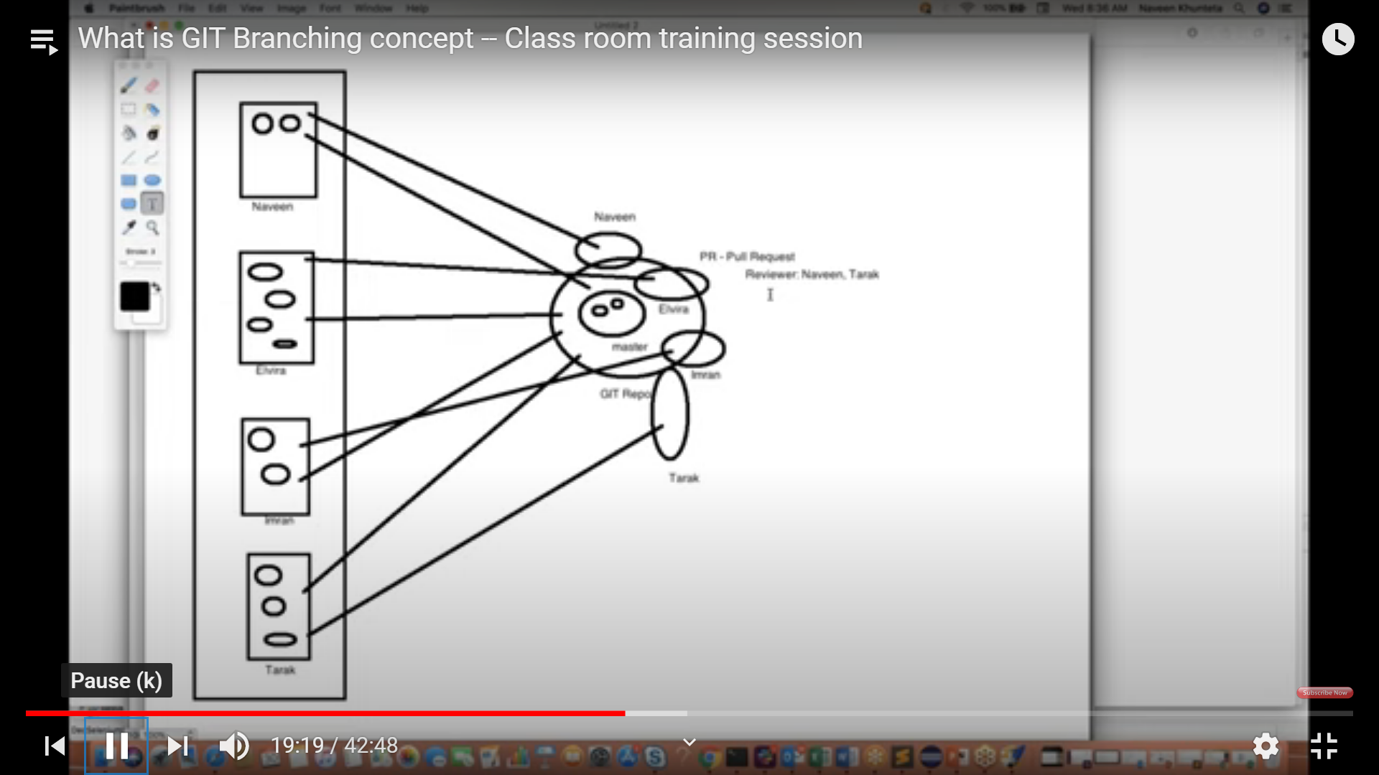

**Stashing**

Stashing concept comes on multiple branches. When we are creating one branch (feature2) and make any changes on any of the file and then save it into ‘stash(a temporary location)’.

Commands used:

**git checkout -b feature2 (creating new branch feature2 with head pointing towards it)**

**gedit command opens any file for change (gedit filename)**

**git stash save ‘feature changed’**

Now move towards already created branch(feature1) and apply the stash changes on it. After saving the changes to feature1 commit the changes on feature1

Commands Used:

git stash apply stash ID (changes not staged for commit)

git commit -m “commit the final changes for both branches”

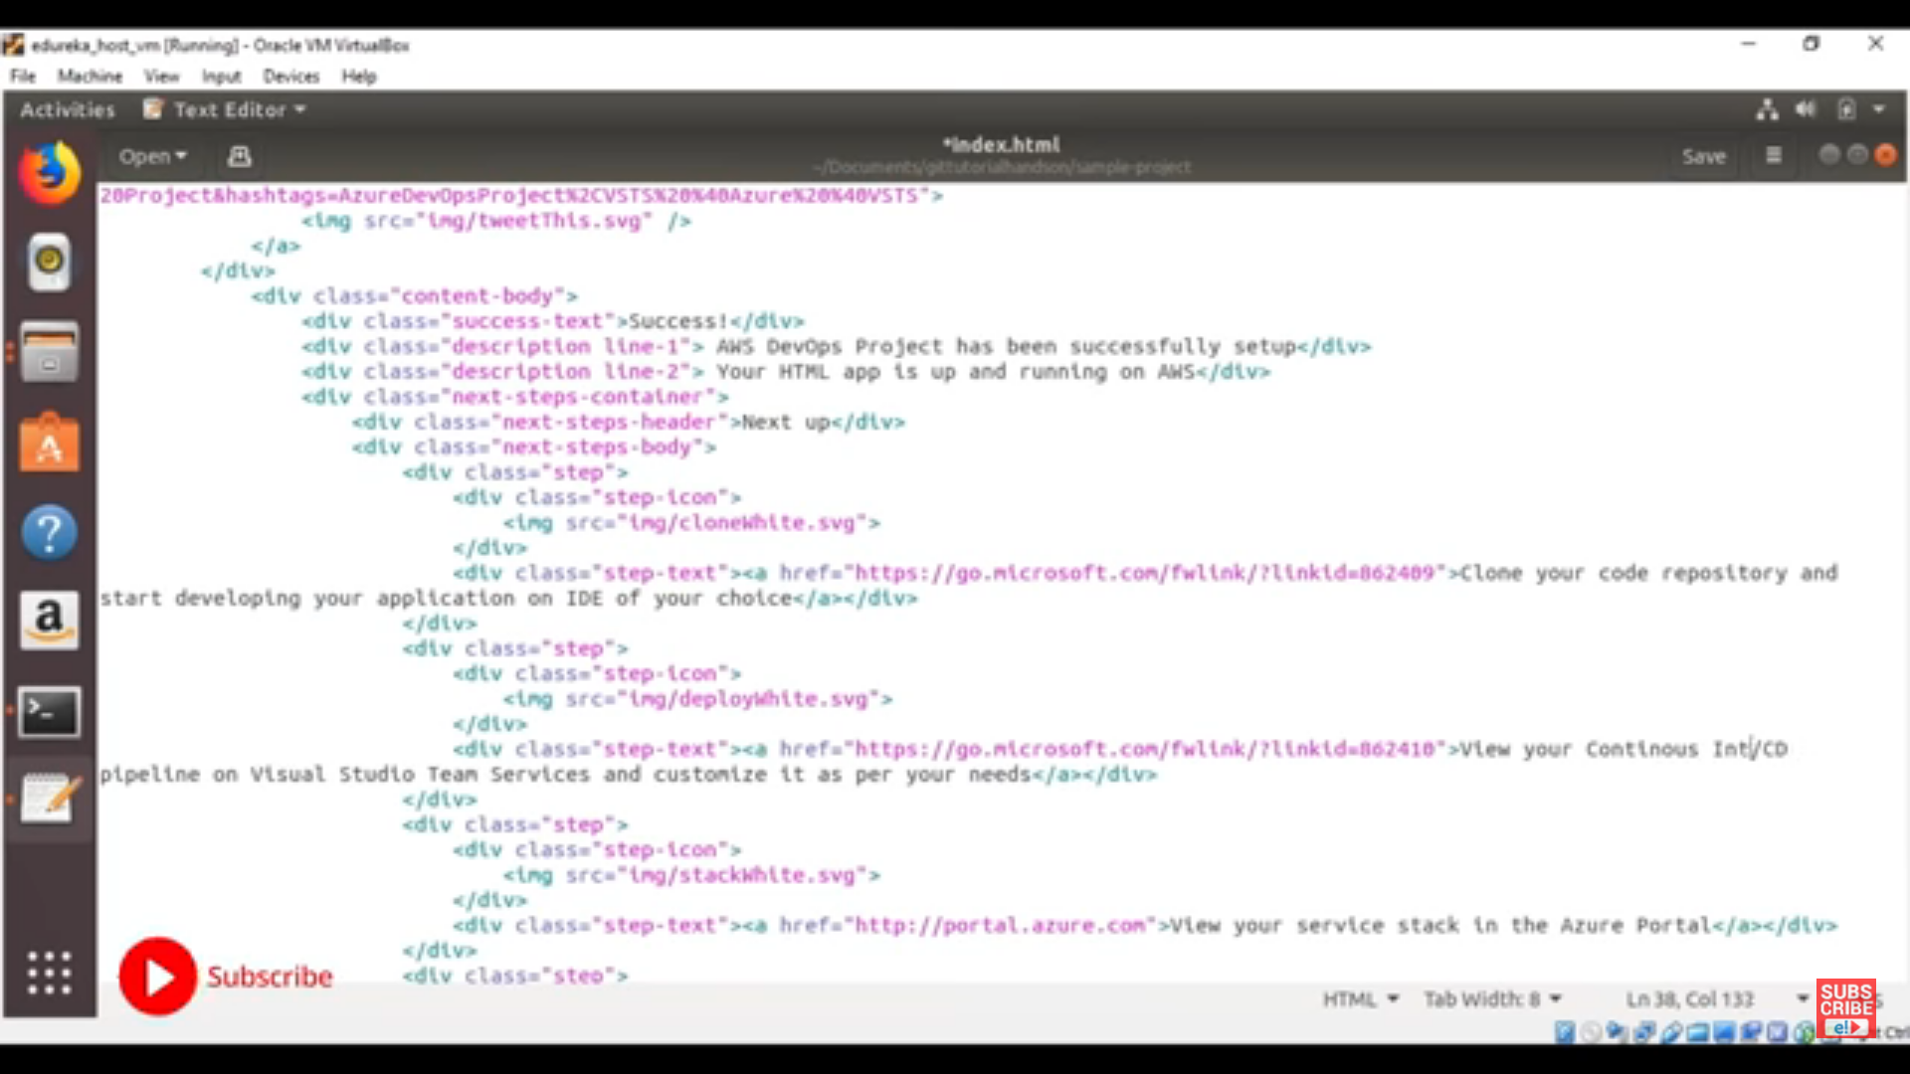

**Workflow on the following-**

**Creating and switching head towards another branch ‘feature2’ and then editing an existing file and stashed it. After that, if we want to apply the changes from feature2 branch into another branch ‘feature1’ we can use**

**Git stash apply stash id(feature2branch)**

**Note: we can get list of stashed by git stash list**

Eedit command opens any file to change

Git diff command shows the differences

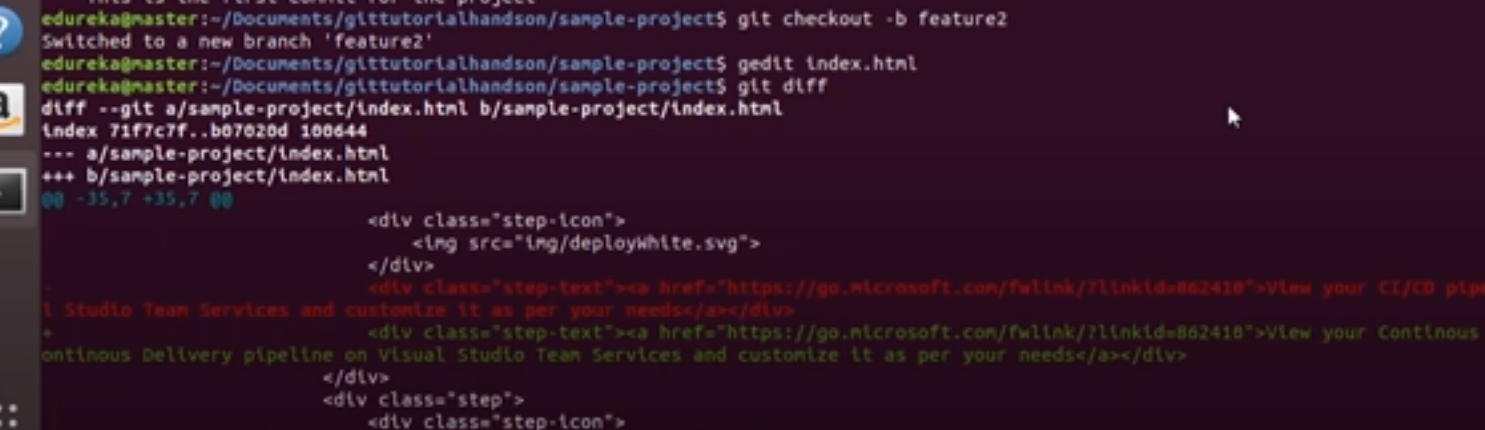

Stashing: If we want to save our uncommitted changes in a temporary directory we use stash

Git stash save ‘message’

After that if we want to see the list we will use git stash list



Now we are applying the changes in feature2 branch (stash changes) into feature1 branch by the following

Git stash apply stashed of feature2

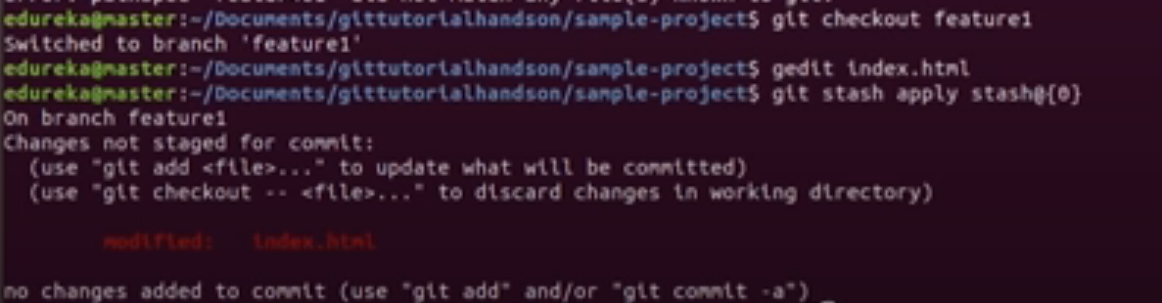

Merge Conflict

Work Flow:

Developer 1 master branch

Developer2: developer branch

Developer 1 has committed the code and push the code in remote repo with files 1,2,3,4,5

Now, developer2 has cloned the code to create his new local repo and then contining his changes as following

1,2,3,4,5 + a,b,c,d,e

Now suddenly developer1 deleted file 4,5 and committed the changes. Since he still didn’t push the code into remote repo and now if developer2 trying to merge his developer branch wit master brach he will see the ‘merge conflict issue” as his commit is not aware of the deletion of file 4,5 from developer 1

